1. Goto ServiceNow and select below Option for any Cloud Account Provisioning

1. Provide project detail and the project name (Name for your cloud account)

1. Provide, PM, Director (who will approve), Business justification. Select the Cloud Service Provider (AWS, Azure, GCP)

1. Get PM Approval for the Snow request

1. Get Director Approval

1. Once it is approved by the Director, you will receive an email from Global Procurement Team for responding to a questionnaire



1. Once it is approved by Global Procurement POC, it will go for L1/L2 procurement approval (No action needed from you)
2. You will receive welcome email after the approval



1. To Provide access to Cloud Account, use below SNOW option

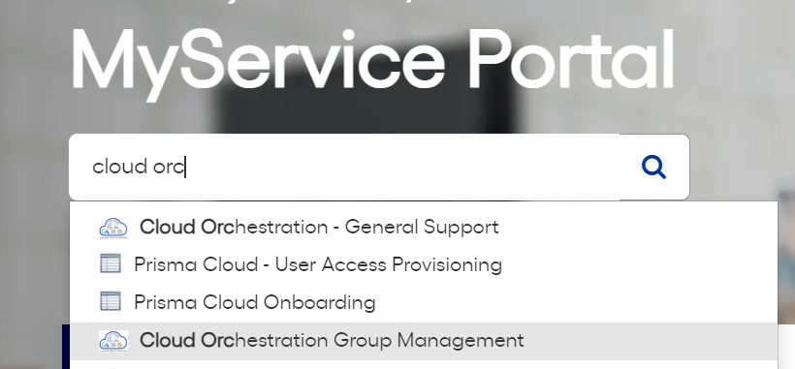

1. Provide Group Name (Available in welcome email) and user name

1. User will be automatically provisioned. Share the Launcher link (available in welcome email) to the added user to access the environment